Scripting Task

Task Description:

- Create a shell script to print the HTTP error code of guvi.in & print, the success/failure message based on the error code response.

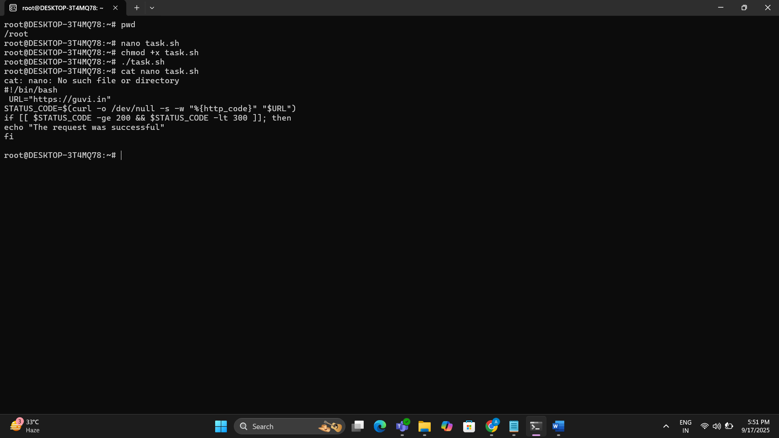

- Given a file, replace all occurrence of the word "give" with "learning" from 5th line till the end in only those lines that contain the word "welcome"

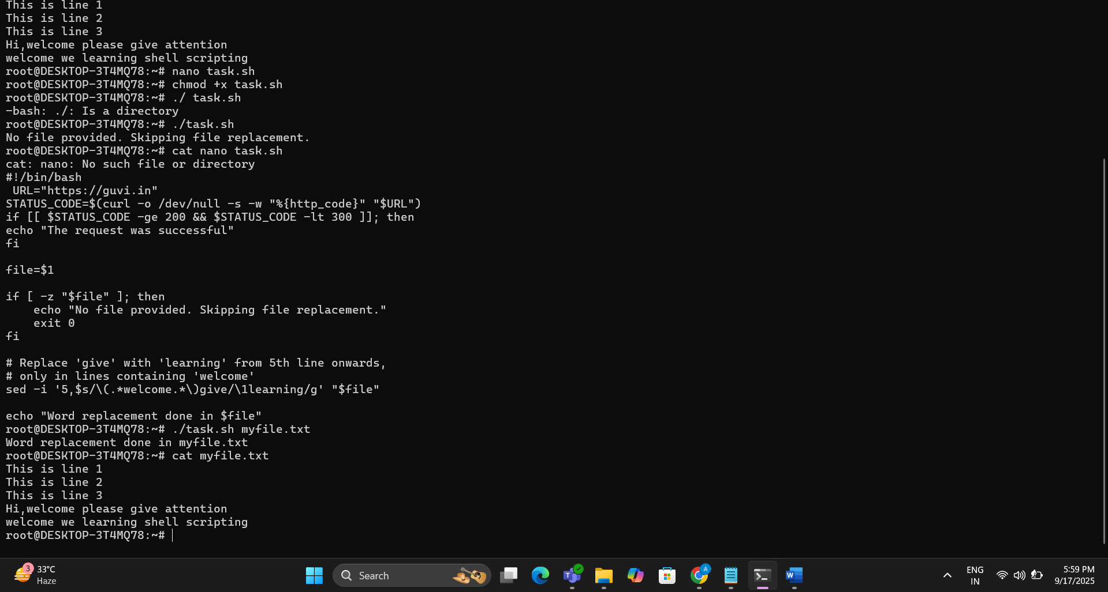

Script:-

#!/bin/bash
URL="https://guvi.in"
STATUS_CODE=$(curl -o /dev/null -s -w "%{http_code}" "$URL")
if [[ $STATUS_CODE -ge 200 && $STATUS_CODE -lt 300 ]]; then
echo "The request was successful"
fi

#!/bin/bash

file="$1"

sed -i '5,${
/welcome/ s/give/learning/g
}' "$file"

